CPU Scheduling Project
CSE 4300 Fall 2025, Wei Zhang

Abhinav Hazarika, Daniel Bokshan, Eric Wang, Vin Gluck

Process Block

The following block represents one process in our program.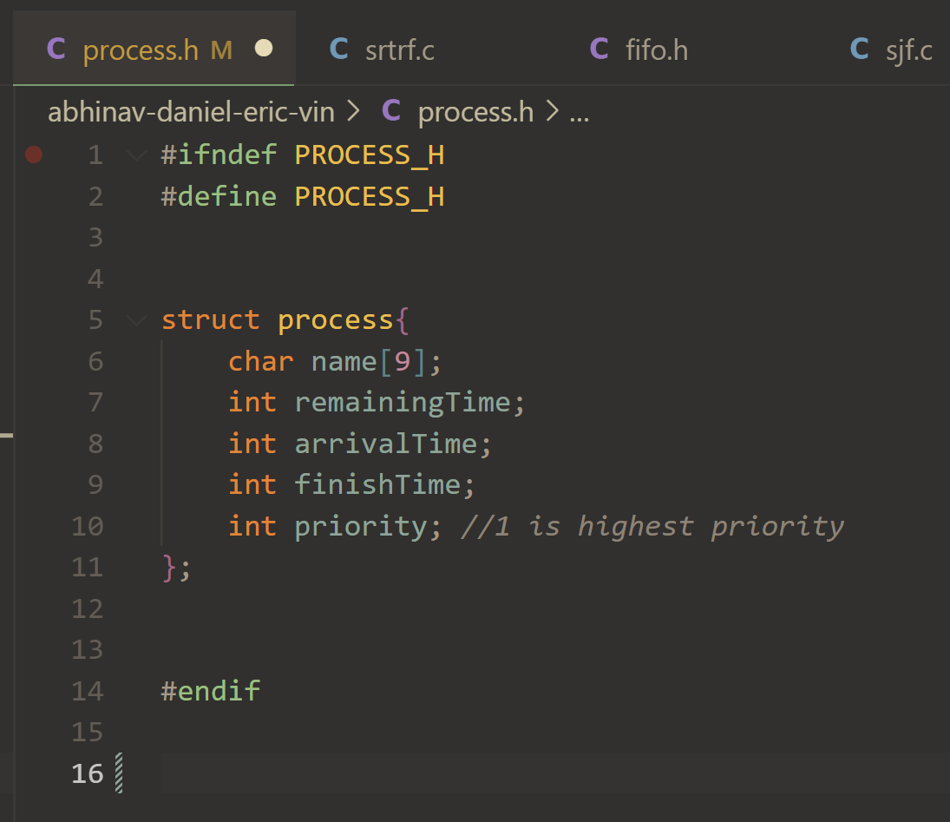

This struct contains attributes necessary for scheduling, including the name of the process (for our testing, it was “processA”, “processB”, etc, so we only allocated memory for 9 characters in that array including the null character marking the end. The remainingTime is loaded with the total time of the process, and it is decremented each timestep the process is executed. The arrivalTime is populated with the time the process finished once remainingTime reaches 0 by the process’s respective scheduling policy. Lastly, the priority is an integer 1-4, where 1 is the highest priority and 4 is the lowest priority.

Schedule-main.c
Schedule-main is the central entry point of our scheduler. It contains a function which takes in the entire array of processes and its size, as well as the number of time steps to simulate.
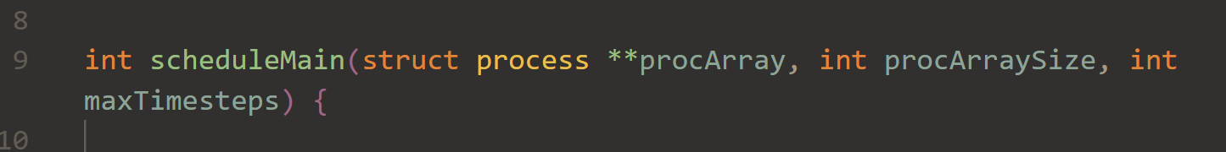

The function allocates memory for the 4 queues representing the different priority levels, as well as index variables to keep track of where items can be inserted into those queues.
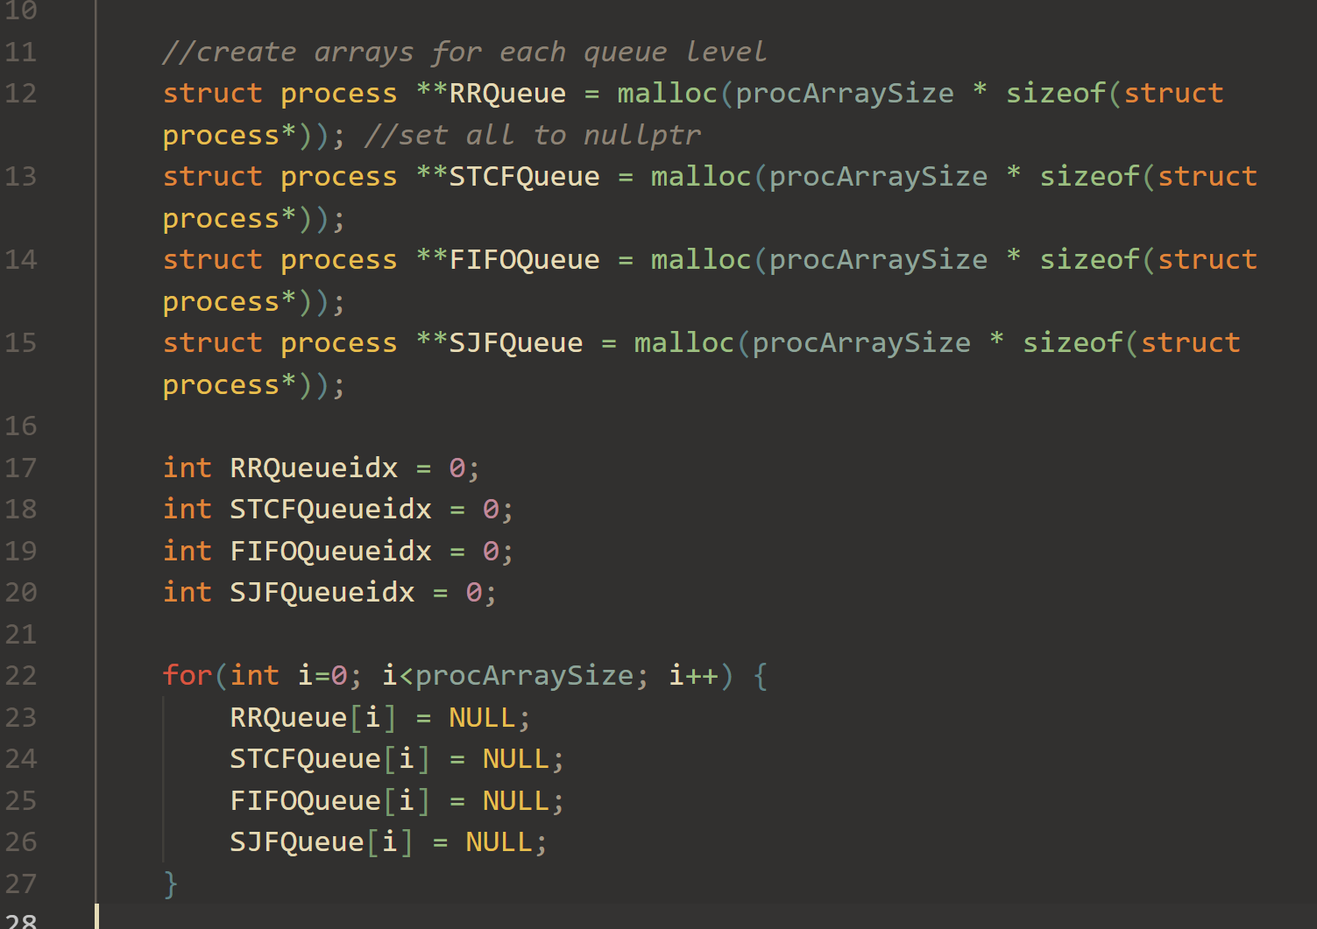

The function prints the contents of all the process blocks passed into the system for debugging purposes.
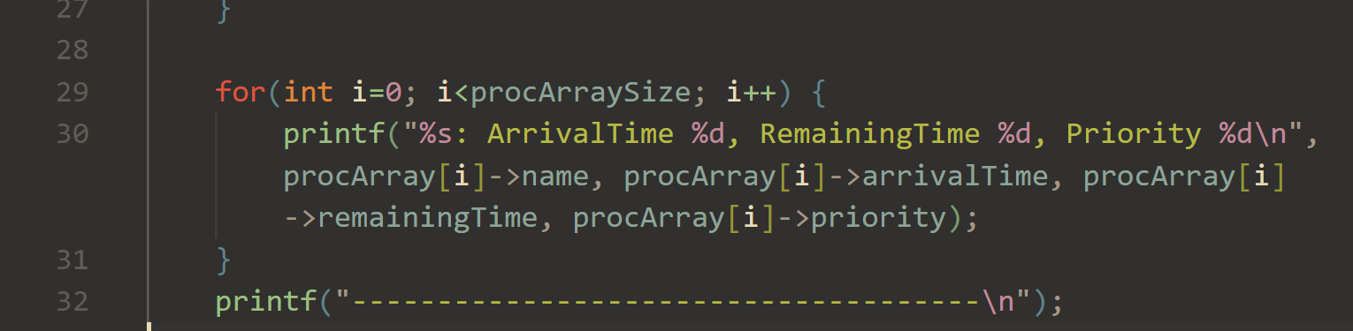

After the preliminary setup is done, the function iterates through the requested time steps and places a pointer to the process struct of any newly arriving processes in that time step, making sure to update the index of the next free memory location in that queue.
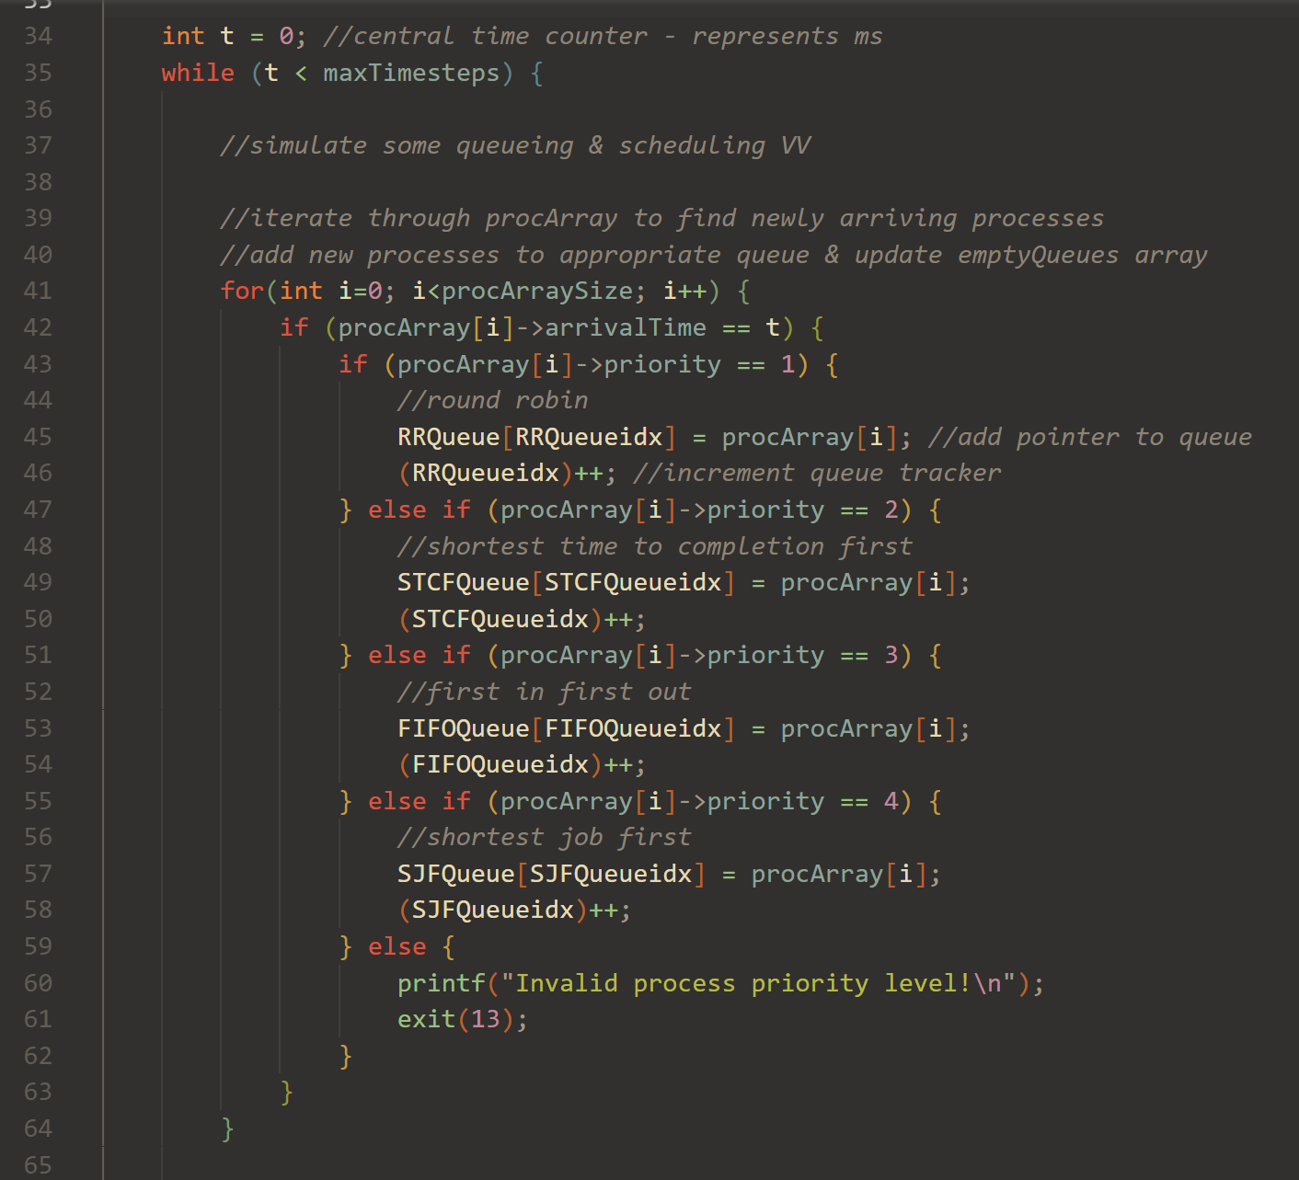

Now that the queues are updated, the function will call the policy function for the highest-priority queue which has waiting processes in it, making sure to pass a reference to that queue index to make sure it is updated (decreased) properly on the policy side. The order of the priority levels is as follows:
1 (highest priority) - Round Robin
2 – Shortest Remaining Time to Completion First
3 – FIFO
4 – Shortest Job First
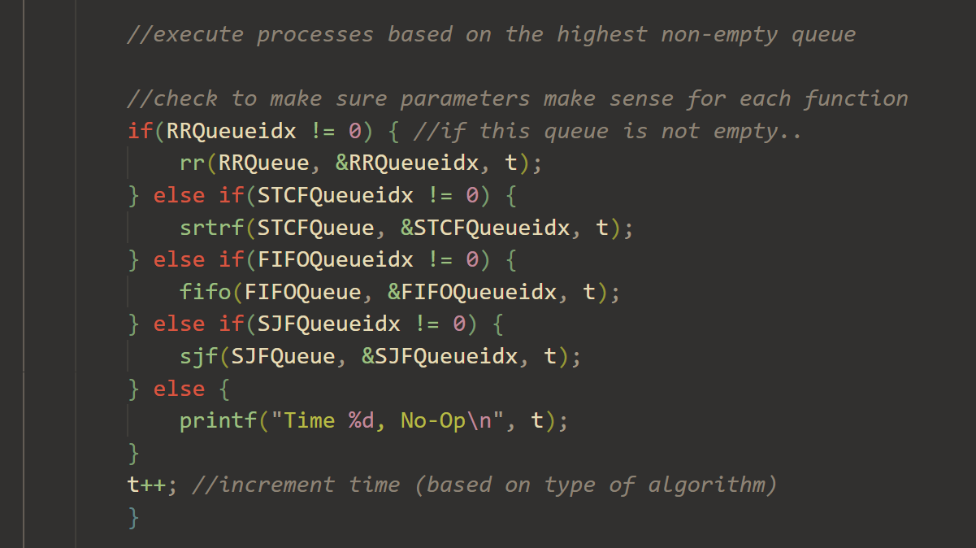

This loop repeats for every time step. This means that every process will be decremented from remainingTime one at a time. This also means that the lower-priority algorithms (FIFO and SJF) which are not normally preemptive can be interrupted by higher-priority queues if a job arrives which needs the CPU time.

Finally, the memory allocated for the queue arrays is freed. Any further logging/printing is done by the policies or test function.
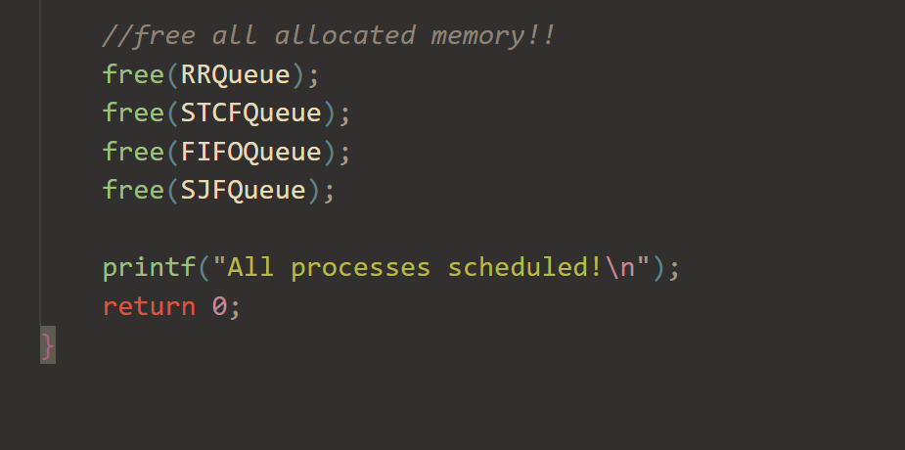

FIFO Algorithm Policy – fifo.c/h
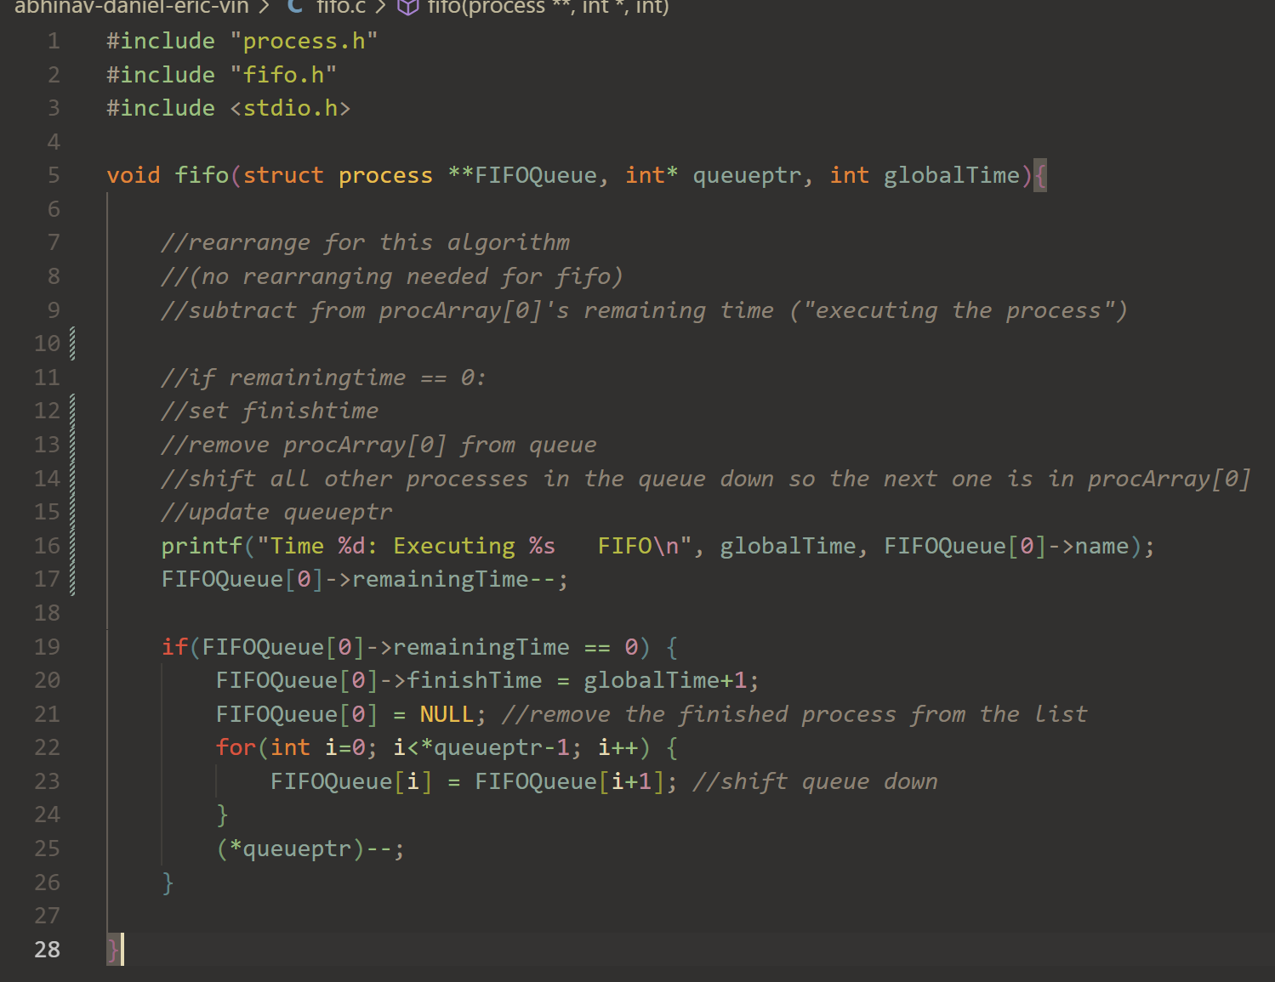The FIFO Policy does not require any swaps or rearranging of the process pointers in the struct passed in from the main function because the algorithm simply executes the processes in the order of arrival, which is the exact order that the central schedule-main function inserts them in. Therefore, this function simply handles the logic of decrementing the remainingTime on the process at the front of the queue, and occasionally pulling it off the queue if it has finished running. Once a job is taken off the queue, all the other jobs are shifted towards the front of the queue and the pointer to the earliest remaining open memory slot is decremented to indicate the freed space.

Round Robin Policy – rr.c/h
static int counter = 0; //Used to keep track of whose turn it is
const int timeQuantum = 1; //A constant value so I can set th time quantum for reset

int tq = timeQuantum; //Keeps track of the remaining time quantum for current process

void rr(struct process **procArray, int *arrayIdx, int globalTime){
int turn = counter%(*arrayIdx);
printf("Time %d: Executing %s RR\n", globalTime, procArray[turn]->name);
procArray[turn] -> remainingTime--;

if(procArray[turn] -> remainingTime <= 0){
procArray[turn] -> finishTime = globalTime+1;
for(int i = turn + 1; i < (*arrayIdx); i++){
procArray[i-1] = procArray[i];
}

(*arrayIdx)--;
tq = timeQuantum;
}
else{
tq --;
if(tq <= 0){
tq = timeQuantum;
counter++;
}
}
}

This function keep track of which process’ turn it is using a static integer, since it persists outside the function calls. There is also a predefined time quantum variable that keeps track of the time quantum. Every time this function is called, it would determine which process to run based on the static counter, and the number of processes in its array.
Then it would run that process for one millisecond and then check if that process is finished.
If so, it would remove this process from round robin queue, update the size of that queue, and reset the time left on the quantum so that the next process in the round robin queue would be able run for the full quantum.
Otherwise, the policy would reduce the quantum by one, and check if it is depleted, which then it would reset the quantum and increase the counter to indicate that it is the next process’ turn.

Shortest Time Remaining Run First

#include "process.h"
#include "srtrf.h"
#include <limits.h>
#include <stdio.h>

void srtrf(struct process **procArray, int *arrayIdx, int globalTime){
int srt = INT_MAX; //shortest remaining time
int pid;
//find shortest remaaining time
for (int i = 0; i < *arrayIdx; i++){
if(procArray[i]->remainingTime <= srt){
srt = procArray[i]->remainingTime;
pid = i;
}
}
printf("Time %d: Executing %s SRTRF \n", globalTime, procArray[pid]->name);
//decrement the shortest time since it runs on this tick
procArray[pid]->remainingTime--;
//handle if the job finishes
if(procArray[pid]->remainingTime == 0){

procArray[pid]->finishTime = globalTime + 1;
for(int i = pid; i < *arrayIdx; i++){
procArray[i] = procArray[i+1];
}

(*arrayIdx)--;
}
}

The function takes three functions: **procArray, a double pointer to an array that acts as a queue for the processes with STRF priority. *arrayIdx, which has the value of the current index of the last item in the queue. globalTime, which allows us to track finish times for processes.

The function first begins by going through the entire queue and finding the shortest remaining time function and then saves its position in queue. The function then prints out a statement to let the user know that the current process is running on a specific CPU tick. Afterwards, it decrements the process’s saved remaining time. If it happens to reach zero, then the function will dequeue the process and then reduce the arrayIdx value to indicate that the queue has been shortened.

This function returns nothing.

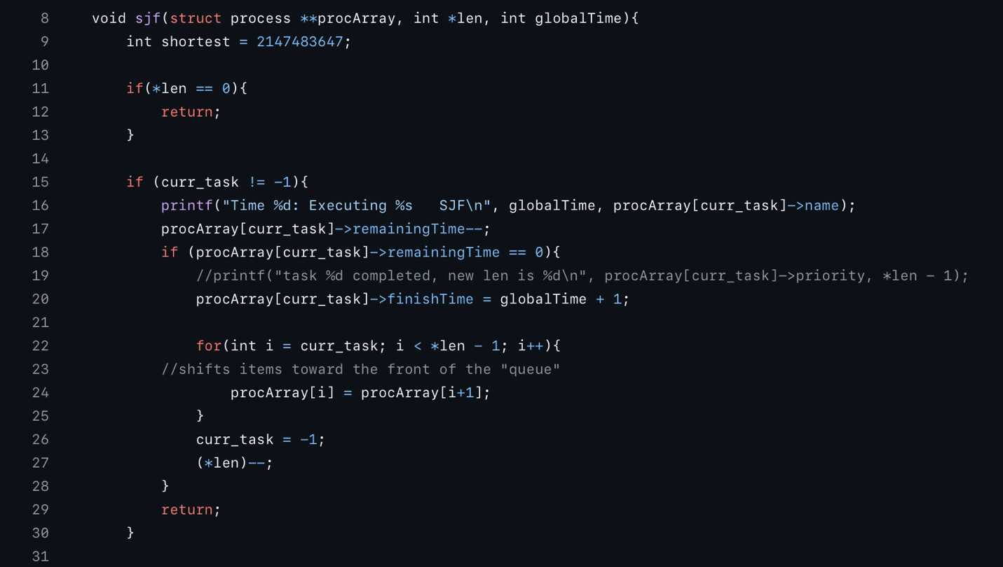
Shortest Job First
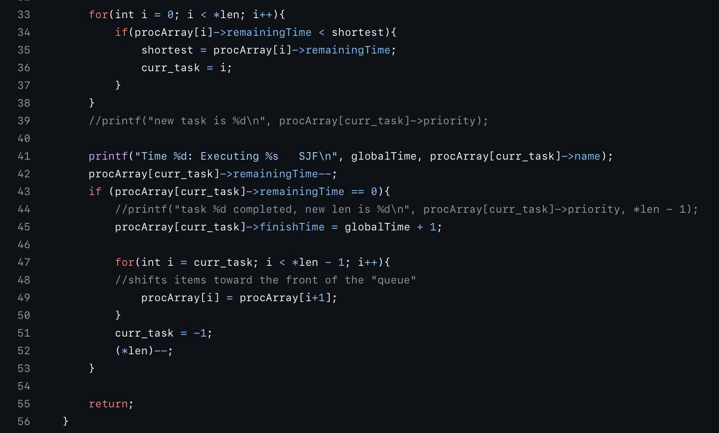
The implementation of SJF is split into 3 main parts. The fist part is an if loop that checks if the queue is empty. If it is then the function will just return. The next part checks if there is a task that is currently running and cannot be interrupted. If so, it will do the task by decrementing time remaining and then it will check if the task is completed and shift the array as needed.
The third part of the code happens when there is not a current task. It will check for the shortest task in the queue and then perform the task. Then it checks if the task is finished in which it will adjust the queue.

Testing:

Combined Testing
struct process* createProcess(char name[9], int remainingTime, int arrivalTime, int priority) {
struct process* newProcess = (struct process*)malloc(sizeof(struct process));

strcpy(newProcess->name, name);
newProcess->remainingTime = remainingTime;
newProcess->arrivalTime = arrivalTime;
newProcess->priority = priority;

return newProcess;
}

void testA(){
struct process *processA = createProcess("processA", 5, 0, 4);
struct process *processB = createProcess("processB", 7, 0, 4);
struct process *processC = createProcess("processC", 4, 0, 3);
struct process *processD = createProcess("processD", 4, 12, 1);
struct process *processE = createProcess("processE", 4, 12, 1);
struct process *processF = createProcess("processF", 20, 30, 4);
struct process *processG = createProcess("processG", 5, 32, 2);
struct process *processH = createProcess("processH", 7, 35, 2);
struct process *processI = createProcess("processI", 1, 35, 2);
struct process *processJ = createProcess("processJ", 3, 41, 3);
struct process *processK = createProcess("processK", 2, 42, 3);
struct process *processL = createProcess("processL", 5, 57, 1);
struct process *processM = createProcess("processM", 5, 58, 1);
struct process *processN = createProcess("processN", 7, 75, 2);
struct process *processO = createProcess("processO", 4, 77, 2);

struct process *processes[] = {processA, processB, processC, processD, processE, processF, processG, processH, processI,
processJ, processK, processL, processM, processN, processO};

scheduleMain(processes, 15, 100);

We created 15 different processes to run on the multi-level queue scheduler to test various scenarios that may appear for a CPU scheduler, such as a handling multiple priorities, handling no tasks, and skipping queues/priorities without tasks.
This runs the main scheduler with all the processes. After it is done running, it prints all the finish time, asserts by comparing the finishing time of each task to make sure that the policies and the scheduler main ran correctly, and then frees all the processes (Not shown in code block)

Individual Testing
Prior to making the main test case, we all ran individual test cases to ensure code functionality of each discipline.
#include"process.h"
#include <stdio.h>
#include <stdlib.h>
#include "fifo-schedulemain.h"
#include <string.h>

// compile command
// gcc test-fifo-test.c fifo-schedulemain.c fifo.c

int main(void) {

//create array of processes

struct process *processA = (struct process*)malloc(sizeof(struct process));
struct process *processB = (struct process*)malloc(sizeof(struct process));
struct process *processC = (struct process*)malloc(sizeof(struct process));
struct process *processD = (struct process*)malloc(sizeof(struct process));
int procArraySize = 4;

processA->remainingTime = 6;
processB->remainingTime = 2;
processC->remainingTime = 15;
processD->remainingTime = 3;

processA->arrivalTime = 0;
processB->arrivalTime = 0;
processC->arrivalTime = 0;
processD->arrivalTime = 0;

processA->priority = 3;
processB->priority = 3;
processC->priority = 3;
processD->priority = 3;

char pAname[] = "processA";
char pBname[] = "processB";
char pCname[] = "processC";
char pDname[] = "processD";

strcpy(processA->name, pAname);
strcpy(processB->name, pBname);
strcpy(processC->name, pCname);
strcpy(processD->name, pDname);

struct process *processArray[] = {processA, processB, processC, processD};

//run scheduler

scheduleMain(processArray, procArraySize, 30);

//print out finish times
printf("Finish times:\n");
for(int i=0; i<procArraySize; i++) {
printf("process %d: %d\n", i, processArray[i]->finishTime);
}

free(processA);
free(processB);
free(processC);
free(processD);

return 0;
}

This code block is for setting up the individual test case for the FIFO scheduler. All individual testing was done to confirm that each algorithm for each discipline worked properly before integrating into the main scheduler. Several processes are created and have their attributes set, with varying values according to the discipline being tested, and then put into a queue, which is then sent to a modified scheduleMain function, shown below:
#include "process.h"
#include <stdio.h>
#include <stdlib.h>
#include "fifo.h"

int scheduleMain(struct process **procArray, int procArraySize, int maxTimesteps) {

//create arrays for each queue level
struct process **FIFOQueue = malloc(procArraySize * sizeof(struct process*));

int FIFOQueueidx = 0;

for(int i=0; i<procArraySize; i++) {
FIFOQueue[i] = NULL;
}

//array to keep track of empty/non-empty queues - empty by default
int emptyQueues[] = {
1, //RoundRobin
1, //STCF
1, //FIFO
1 //SJF
};

int t = 0; //central time counter - represents ms
while (t < maxTimesteps) {

//(leftovers from previous run)
if(FIFOQueueidx == 0) {
emptyQueues[2] = 1;
}

//simulate some queueing & scheduling VV

//iterate through procArray to find newly arriving processes
//add new processes to appropriate queue & update emptyQueues array
for(int i=0; i<procArraySize; i++) {
if (procArray[i]->arrivalTime == t) {
if (procArray[i]->priority == 1) {}
if (procArray[i]->priority == 3) {
//first in first out
FIFOQueue[FIFOQueueidx] = procArray[i];
(FIFOQueueidx)++;
emptyQueues[2] = 0;
} else {
printf("Invalid process priority level!\n");
exit(13);
}
}
}

//execute processes based on the highest non-empty queue

//check to make sure parameters make sense for each function

if(emptyQueues[2] == 0) {
fifo(FIFOQueue, &FIFOQueueidx, t);
}

t++;
}

//free all allocated memory!!
free(FIFOQueue);

printf("All processes scheduled!\n");
return 0;
}

In this modified version of scheduleMain, all code checking the queues of other scheduling disciplines, as well as the code that checks if there is a new arriving process, only concerns itself with the FIFO queue. The code will first queue any arriving processes, which will only be FIFO priority in this case. Afterwards, the code will check if the FIFO queue is empty, and if it is not according to the FIFO item in the emptyQueue (!= 1), then it will run the FIFO scheduler. The code then loops to the next cpu tick. Lastly, memory is freed when time is up. Function returns 0 to indicate successful execution.

